**Methane the Other Greenhouse Gas**

**by Theodore van Kessel**

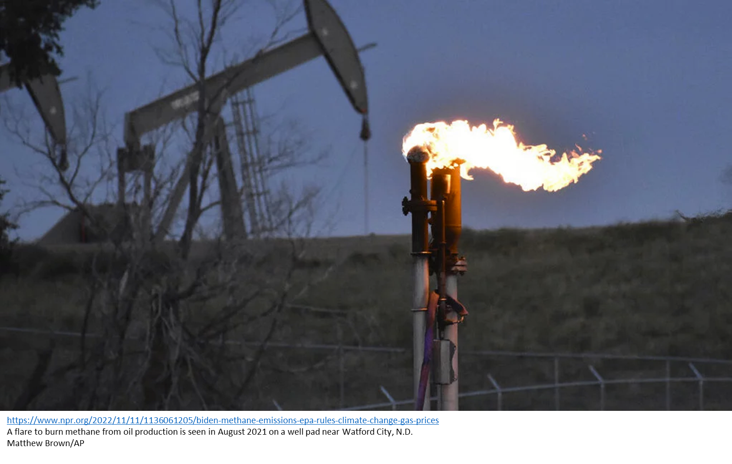

Carbon dioxide takes center stage when we discuss greenhouse gasses and global warming. Methane, the other gas that is less discussed, is almost as significant as carbon dioxide relative to global warming. According to the Environmental Defense Fund 25% of today's global warming is driven by methane from human actions [1]. Of these emissions approximately 29% are from oil and gas operations with the remaining contributions coming from agriculture (enteric fermentation) and many other sources.

It is hoped that oil and gas operations present a large and available opportunity to reduce greenhouse gas emissions. For this to occur, we must know where to focus effort. There are many commonly held beliefs when it comes to emissions from the oil and gas industry. Among these are:

1. The largest 20% of emitters account for 80% of the total methane emissions.
2. Most methane emissions are from leaks in pipes.
3. Most methane emissions are from the flaring of waste gas.

The point of this discussion is to evaluate the above beliefs in using an actual dataset. While a great deal of data is being generated by aerial surveys and satellites. Most of the data is not in a usable form and has not been analyzed to find gas plumes, compute the corresponding emission rate or associate them with particular equipment.

One notable exception to this is an aerial survey done by NASA/JPL in 2019. This survey was performed with aircraft using infrared cameras [4]. It is available from several sources but in this case, I used the supporting information from an excellent paper by Cusworth [2] as part of the supporting information [2,3].

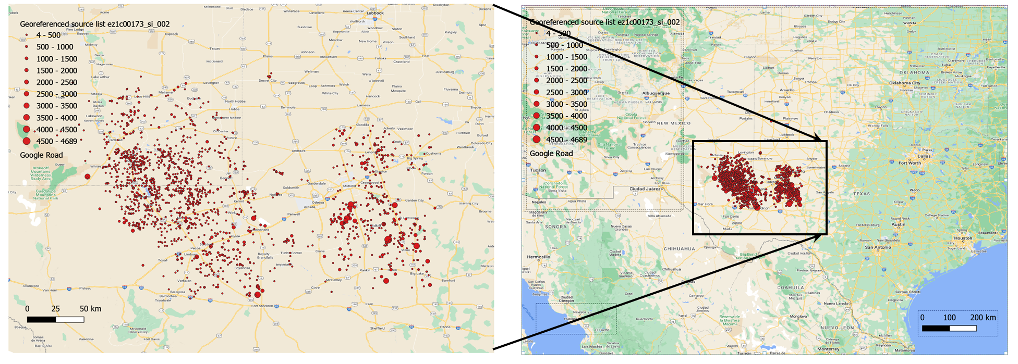

Illustration of observed plume locations in the NASA/JPL dataset.

The illustration above shows the location plume observations from the NASA/JPL Methane dataset in the Permean Basin in west Texas. Approximately 3000 methane plumes were observed. These plumes were classified as to the source of the emission and the emission rate was computed. Finally, the presence or absence of active or inactive flares was observed.

**Does the 80/20 rule apply to methane emissions?**

The charts below show the distributions of methane emissions by size. Clearly there are significantly more small emissions (leaks) than large ones. For this reason, it is a common belief that large emissions account for most of the leaks.

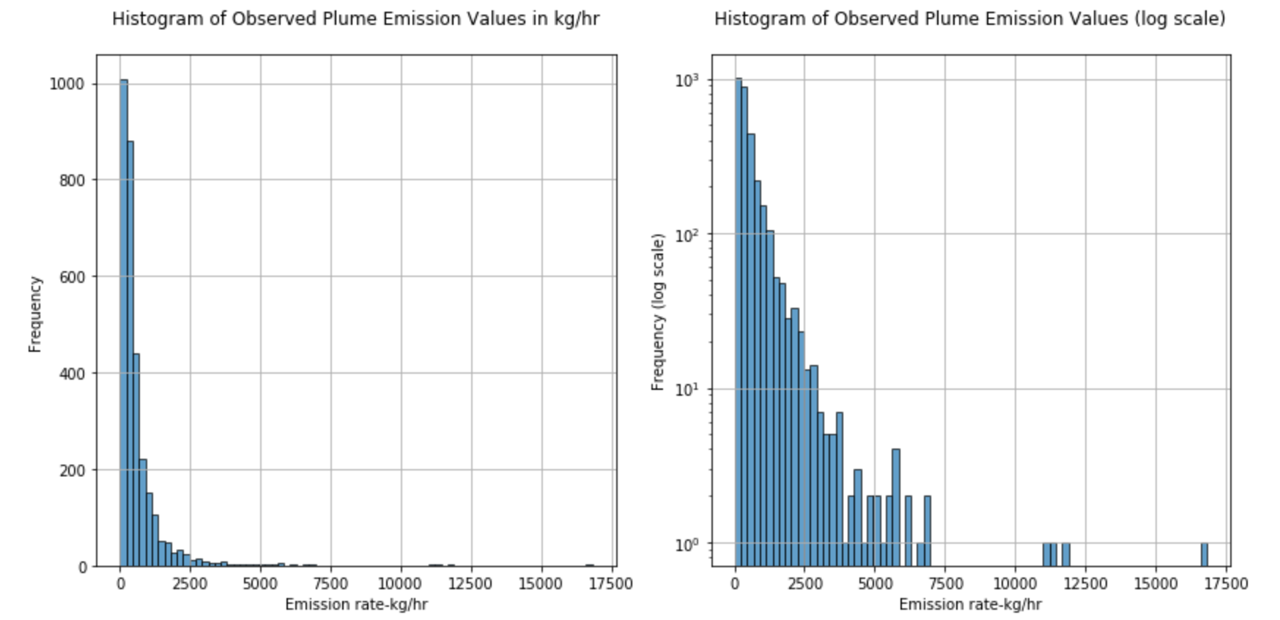

If we dive into the dataset, sort the emissions from largest to smallest and then compute the cumulative emission rate, we see in the charts below that cumulative emission rate reaches 80% approximately halfway into the distribution of emission size around 250 kg/hr.

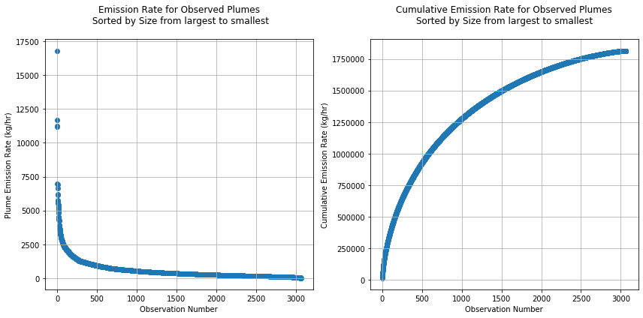

This is not a trivial amount of gas but it is quite far from 20% We conclude: The fraction of observations at 80% of total emissions: 0.449 or 44%.

Put another way, the largest half of the observed methane emissions account for 80% of the total emitted methane. If we move the threshold to 50%, we see that the 15% largest emissions account for half of the methane released by oil and gas operations. While not an 80/20 split, the data suggests that a relatively small number of emissions are responsible for a significant fraction of the total methane emissions.

**Do methane emissions vary significantly by type of equipment?**

It is worth noting that methane is emitted under normal operation of oil and gas equipment for many reasons such as the venting of tanks, flaring etc. as well as abnormal events such as a pipe rupture.

We examine this data in the chart below. We see that for the types of equipment considered there is not a significant variation by equipment type. Pipeline leaks do contribute significantly to the total methane emissions, but they are comparable in magnitude to the other types of equipment considered in this dataset.

We conclude that the sources of methane leaks are diverse without a single dominant contributor based on this dataset.

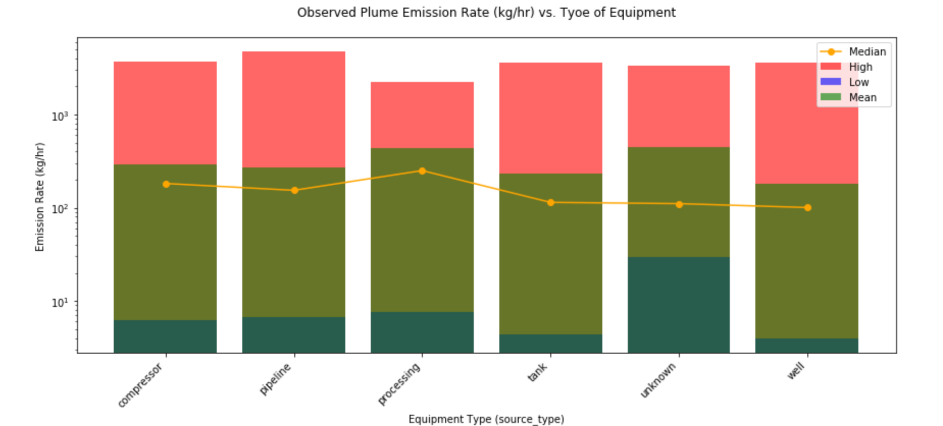

**What fraction of emissions occur in the presence of flaring?**

The dataset classifies whether flares were observed at or near the source of the observed emission plume and whether or not they were active at the time of observation.

We see in the first chart that the range of emission rates for observed plumes appears to be broader for cases where flares were not observed. In the cases where either an active of inactive flare was observed the range is narrower. The plumes corresponding to an inactive flare show larger emission rates than those of active flares. This was a bit surprise given that flares are not 100% efficient (ranging from 65% to95% depending on conditions)

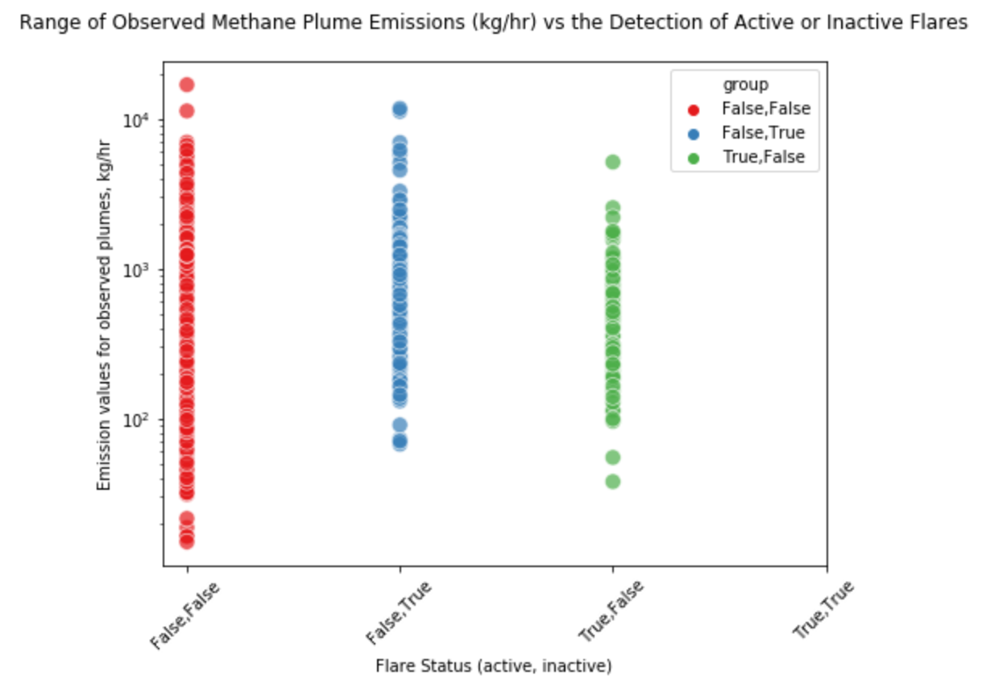

If we simply count the number of plumes that correspond to each category (see figure below), we see that largest number correspond to the case where no flare was detected.

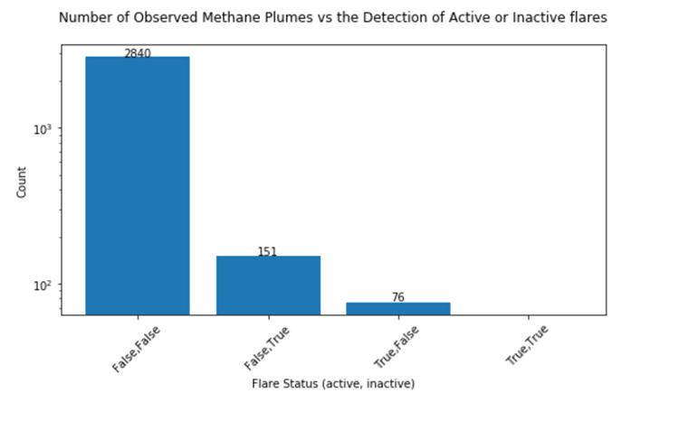

The next largest is the case where an inactive flare was observed. Finally, the smallest was the case where active flares were detected.

We conclude that most plumes occur when no flares are detected.

**What should we do:**

1. **Urge oil and gas companies to monitor and correct emissions from infrastructure.**
2. **Urge government to regulate methane emissions.**

Fortunately, methane emission limits are being re-instated as part of the EPA’s overall plan to reduce emissions of methane [6].

**References:**

1. Methane: A crucial opportunity in the climate fight https://www.edf.org/climate/methane-crucial-opportunity-climate-fight

2. Cusworth, D.H., Duren, R.M., Thorpe, A.K., Olson-Duvall, W., Heckler, J.W., Chapman, J.W., Eastwood, M.L., Helmlinger, M., Green, R.O., Asner, G.P., Dennison, P.E., & Miller, C.E. (2021). Intermittency of Large Methane Emitters in the Permian Basin. *Environmental Science and Technology Letters*.

3. https://pubs.acs.org/doi/suppl/10.1021/acs.estlett.1c00173/suppl_file/ez1c00173_si_001.xlsx

4. https://pubs.acs.org/doi/suppl/10.1021/acs.estlett.1c00173/suppl_file/ez1c00173_si_002.xlsx

5. Methodology for EDF’s Permian Methane Analysis Project (PermianMAP) <https://www.edf.org/sites/default/files/documents/PermianMapMethodology_1.pdf>

6. "Biden tightens methane emissions rules, even as the U.S. pushes for more oil drilling"

https://www.npr.org/2022/11/11/1136061205/biden-methane-emissions-epa-rules-climate-change-gas-prices

7. Thorpe, A. K., et al., Mapping methane concentrations from a controlled release experiment using the next generation airborne visible/infrared imaging spectrometer (AVIRIS-NG) , Remote Sensing of Environment, 104-115, 2016, https://doi.org/10.1016/j.rse.2016.03.032